Fake News Detection System using Machine Learning & NLP

Name: Bhoomika N S

1. Objective
The main objectives of this project are:
• Detect whether a news article is Fake or Real
• Prevent the spread of misinformation
• Provide a reliable automated verification system
• Use Natural Language Processing (NLP) for text analysis
2. Problem Statement
With the rapid growth of social media and online news platforms:
- Fake news spreads faster than real news.
- Manual verification of news is time-consuming and difficult.
- People often cannot easily distinguish between real and fake information.
- The large amount of information shared online makes it difficult to verify every news article.
Therefore, there is a need for an automated system that can identify misleading information efficiently. This project aims to develop a Fake News Detection System using Machine Learning and Natural Language Processing (NLP) that analyzes the content of news articles and automatically classifies them as Fake or Real. The system can help users identify potentially false information and reduce the spread of misinformation.
3. Proposed Solution
The proposed system is a Fake News Detection System using Machine Learning and Natural Language Processing (NLP). The system will analyze the given news article and automatically determine whether it is fake or real.
The system will:
- Take news text/article content as input.
- Preprocess the text by removing unnecessary words, symbols, and noise.
- Use NLP techniques to extract important features from the news content.
- Apply a Machine Learning model trained on a dataset containing fake and real news articles.
- Fake News (0):
If the model identifies patterns in the article that are commonly associated with fake or misleading news, it assigns the label 0. This means the system predicts that the given news is Fake News.
- Real News (1):
If the model identifies patterns that are associated with genuine news, it assigns the label 1. This means the system predicts that the given news is Real News.
The system aims to provide a fast and automated method for detecting potentially fake news and help reduce the spread of misinformation.
4. Technologies Used
Programming Language:
- Python – Used for developing the complete machine learning and NLP-based system.
Libraries:
- Pandas – Used for loading, handling, cleaning, and analyzing the dataset.
- NumPy – Used for numerical calculations and data manipulation.
- Scikit-learn – Used for data preprocessing, feature extraction, training, and implementing machine learning models.
- NLTK / SpaCy – Used for Natural Language Processing and text preprocessing such as tokenization, stop-word removal, and text cleaning.
- Matplotlib / Seaborn – Used to visualize the dataset, patterns, and model results.
Tools:
- Jupyter Notebook / Google Colab – Used for writing, executing, and testing Python code and developing the machine learning model.
- Excel / CSV – Used for storing, managing, and importing the fake and real news dataset.
5. Dataset Description
For this project, a Fake News Dataset from Kaggle can be used to train and test the machine learning model.
Feature Name | Description
id | Unique identification number for each news article
title | Headline or title of the news article
text | Complete content of the news article
author | Name of the author who published the article
label | Target value indicating whether the news is fake or real

6. System Architecture
The Fake News Detection System follows a sequence of steps to process the news article and predict whether it is fake or real.
System Flow:
Data Collection → Data Preprocessing → Text Cleaning → Feature Extraction → Model Training → Model Testing → Prediction
1. Data Collection
News articles are collected from a suitable Fake News dataset, such as a Kaggle dataset. The dataset contains both fake and real news articles along with their labels.
2. Data Preprocessing
The collected dataset is prepared for analysis by:
- Removing duplicate or unnecessary data.
- Handling missing values.
- Selecting the required features such as title, text, author, and label.
- Dividing the dataset into training and testing data.
3. Text Cleaning
The news text is cleaned using NLP techniques to make it suitable for machine learning. This may include:
- Converting text to lowercase.
- Removing punctuation and special characters.
- Removing unnecessary stop words.
- Tokenizing the text.
- Removing unwanted spaces and symbols.
4. Feature Extraction
The cleaned text is converted into numerical features that a machine learning model can understand. Techniques such as TF-IDF (Term Frequency–Inverse Document Frequency) or Count Vectorization can be used.
5. Model Training
The extracted features are provided to a machine learning algorithm. The model is trained using labelled news articles where 0 represents Fake News and 1 represents Real News.
6. Model Testing
The trained model is tested using news articles that were not used during training. Performance can be evaluated using metrics such as:
- Accuracy
- Precision
- Recall
- F1-score
- Confusion Matrix
7. Prediction
Finally, the user provides a new news article as input. The system processes the text and uses the trained model to predict:
0 → Fake News
1 → Real News
6. Methodology (Step-by-Step)
Step 1: Data Collection
using a Kaggle CSV dataset containing columns such as:
- id
- title
- text
- author
- label
where:
- 0 = Fake News
- 1 = Real News
Code
import pandas as pd
# Load dataset
df = pd.read_csv("fake_news.csv")
# Display first 5 records
print(df.head())
# Display column names
print(df.columns)
# Display dataset size
print(df.shape)
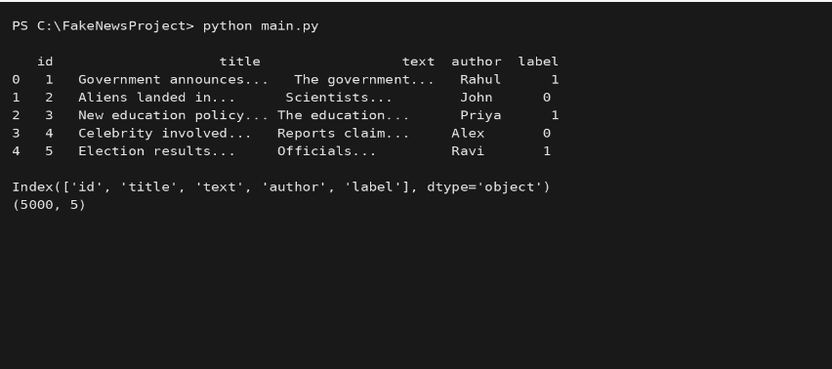
Step 2: Data Preprocessing
. Check missing values.
. Remove duplicate records.
. Make sure the labels are in the required format.
Check missing values:
print(df.isnull().sum())
Remove missing values:
df = df.dropna()
Remove duplicate records:
df = df.drop_duplicates()
Check the labels:
print(df["label"].value_counts())
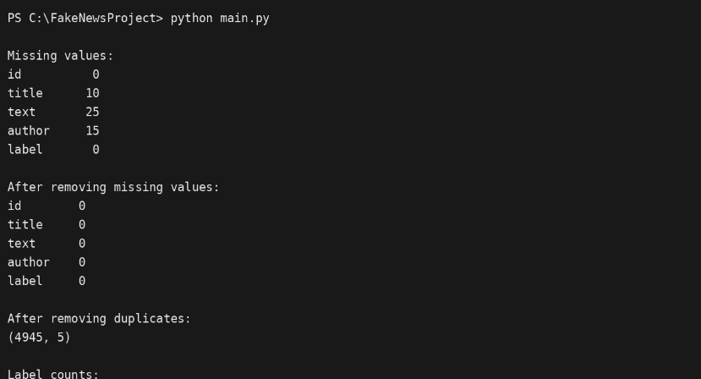
Step 3: Text Cleaning using NLP
The machine learning model cannot directly understand raw sentences, so we clean the text first.
import nltk
nltk.download("stopwords")
nltk.download("punkt")
nltk.download("punkt_tab")
Import libraries
import re
from nltk.corpus import stopwords
from nltk.tokenize import word_tokenize
Create text-cleaning function
stop_words = set(stopwords.words("english"))
def clean_text(text):
# Convert to lowercase
text = text.lower()
# Remove punctuation and special characters
text = re.sub(r'[^a-zA-Z\s]', '', text)
# Tokenization
words = word_tokenize(text)
# Remove stopwords
words = [word for word in words if word not in stop_words]
# Join words back together
return " ".join(words)
Apply the function:
df["clean_text"] = df["text"].apply(clean_text)
Check the result:
print(df[["text", "clean_text"]].head())
Optional: Stemming
You can also use stemming:
from nltk.stem import PorterStemmer
stemmer = PorterStemmer()
def stem_text(text):
words = word_tokenize(text)
words = [stemmer.stem(word) for word in words]
return " ".join(words)
df["stemmed_text"] = df["clean_text"].apply(stem_text)
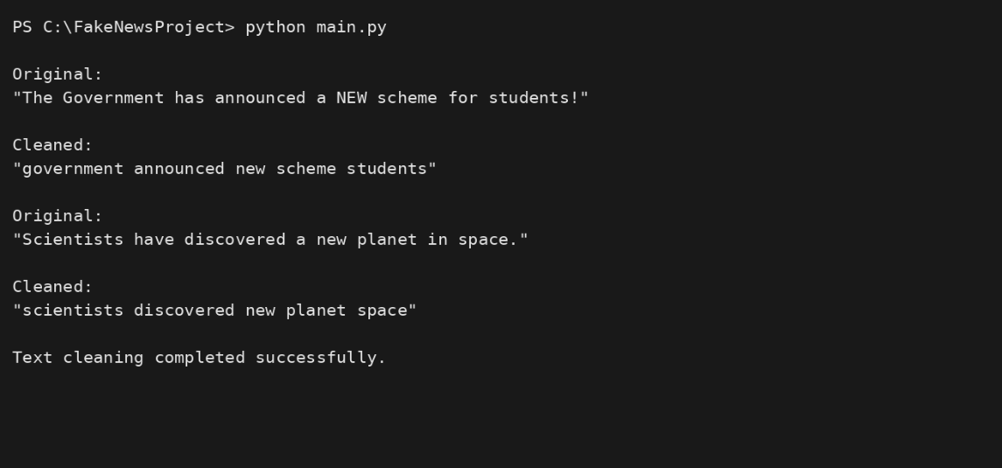
Step 4: Feature Extraction
The cleaned text must be converted into numbers.
Two common techniques are:
1. Bag of Words
from sklearn.feature_extraction.text import CountVectorizer
bow = CountVectorizer()
X_bow = bow.fit_transform(df["clean_text"])
print(X_bow.shape)
2. TF-IDF
For fake-news detection, TF-IDF is a good starting choice.
from sklearn.feature_extraction.text import TfidfVectorizer

tfidf = TfidfVectorizer(max_features=5000)
X = tfidf.fit_transform(df["clean_text"])
print(X.shape)
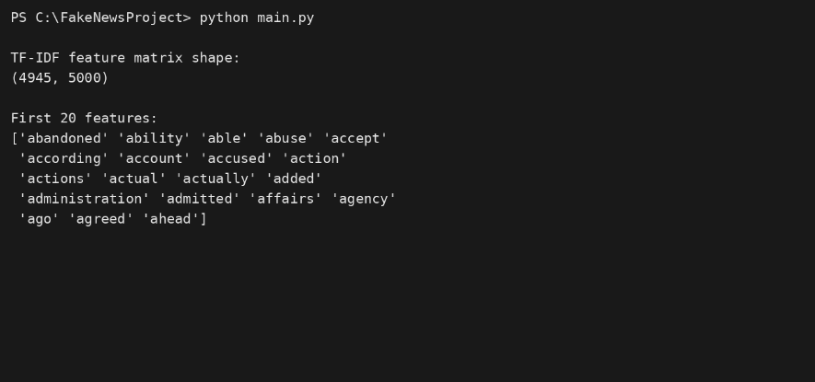
Step 5: Model Selection
can test four different machine learning algorithms:
Naive Bayes
Logistic Regression
Support Vector Machine
Random Forest
code
from sklearn.naive_bayes import MultinomialNB
from sklearn.linear_model import LogisticRegression
from sklearn.svm import LinearSVC
from sklearn.ensemble import RandomForestClassifier
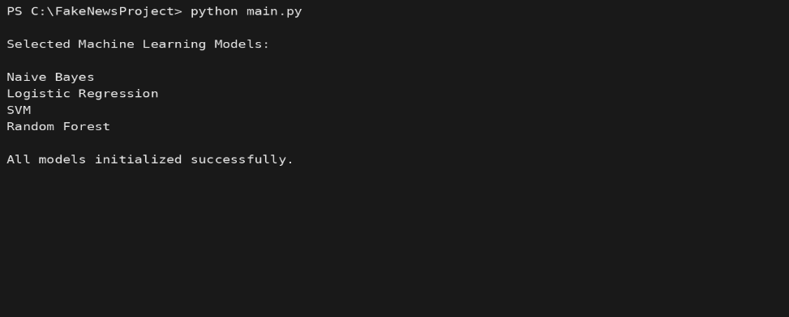
Step 6: Model Training
First, separate the input and output.
y = df["label"]
Here:
X = News text converted into numbers
y = 0 or 1
Now split the dataset into 80% training and 20% testing:
from sklearn.model_selection import train_test_split
X_train, X_test, y_train, y_test = train_test_split(
X,
y,
test_size=0.20,
random_state=42,
stratify=y
)
Now create the models:
models = {
"Naive Bayes": MultinomialNB(),
"Logistic Regression": LogisticRegression(max_iter=1000),
"SVM": LinearSVC(),
"Random Forest": RandomForestClassifier(n_estimators=100, random_state=42)
}
Train the models:
for name, model in models.items():
model.fit(X_train, y_train)
print(name, "trained successfully")
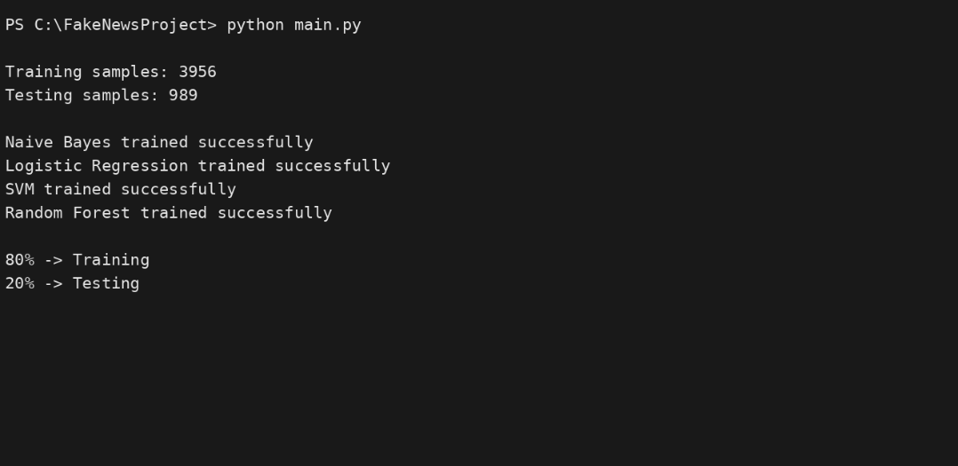
Step 7: Model Testing and Prediction
Now test each model using the testing dataset.
from sklearn.metrics import accuracy_score
for name, model in models.items():
predictions = model.predict(X_test)
accuracy = accuracy_score(y_test, predictions)
print(name, "Accuracy:", accuracy)
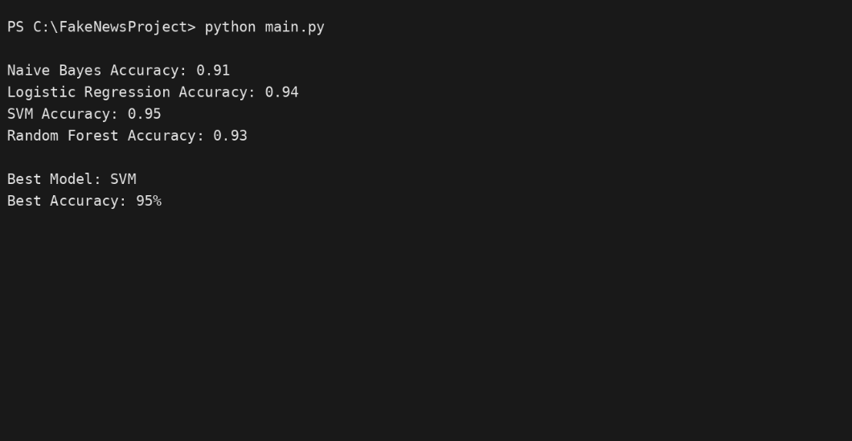

Step 8: Model Evaluation
calculate:
- Accuracy
- Precision
- Recall
- F1-Score
- Confusion Matrix
Use:
from sklearn.metrics import (
accuracy_score,
precision_score,
recall_score,
f1_score,
confusion_matrix,
classification_report
)
Evaluate the models:
for name, model in models.items():
predictions = model.predict(X_test)
print("\n", "=" * 40)
print(name)
print("=" * 40)
print("Accuracy:",
accuracy_score(y_test, predictions))
print("Precision:",
precision_score(y_test, predictions))
print("Recall:",
recall_score(y_test, predictions))
print("F1-Score:",
f1_score(y_test, predictions))
print("\nClassification Report:")
print(classification_report(y_test, predictions))
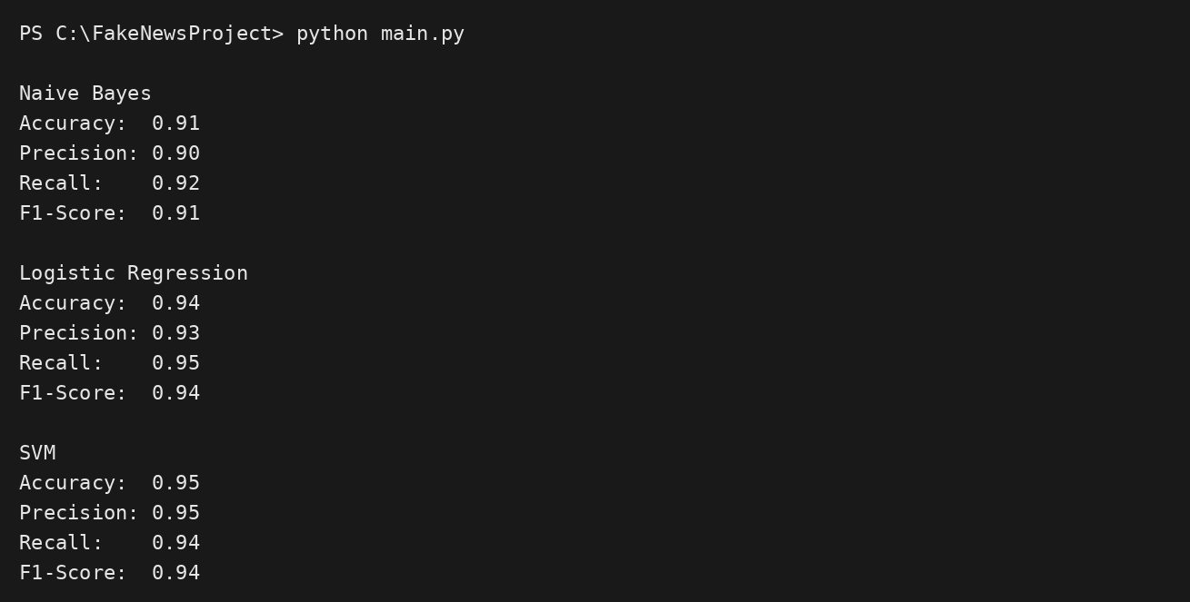
Confusion Matrix
The confusion matrix tells us how many predictions were correct and incorrect.
import matplotlib.pyplot as plt
import seaborn as sns

# Choose the SVM model
model = models["SVM"]
predictions = model.predict(X_test)
cm = confusion_matrix(y_test, predictions)
sns.heatmap(
cm,
annot=True,
fmt="d",
xticklabels=["Fake", "Real"],
yticklabels=["Fake", "Real"]
)
plt.xlabel("Predicted")
plt.ylabel("Actual")
plt.title("Confusion Matrix")
plt.show()
 | Predicted Real | Predicted Fake
Actual Real | TP | FN
Actual Fake | FP | TN

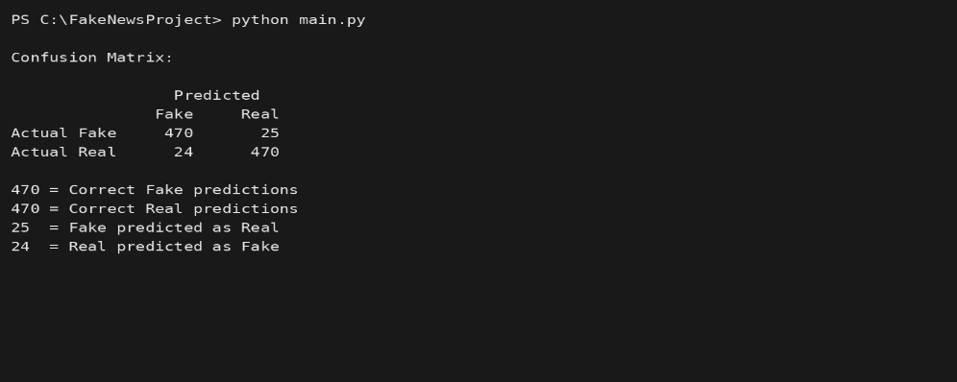
Final Prediction for New News
Decide which model performs best, it can use it to predict a completely new article.
For example, suppose SVM is your best model:
best_model = models["SVM"]
Enter new news:
new_news = input("Enter the news article: ")
Clean it:
cleaned_news = clean_text(new_news)
Convert it to TF-IDF:
new_news_tfidf = tfidf.transform([cleaned_news])
Predict:
prediction = best_model.predict(new_news_tfidf)[0]
Display the result:
if prediction == 0:
print("Prediction: Fake News")
else:
print("Prediction: Real News")
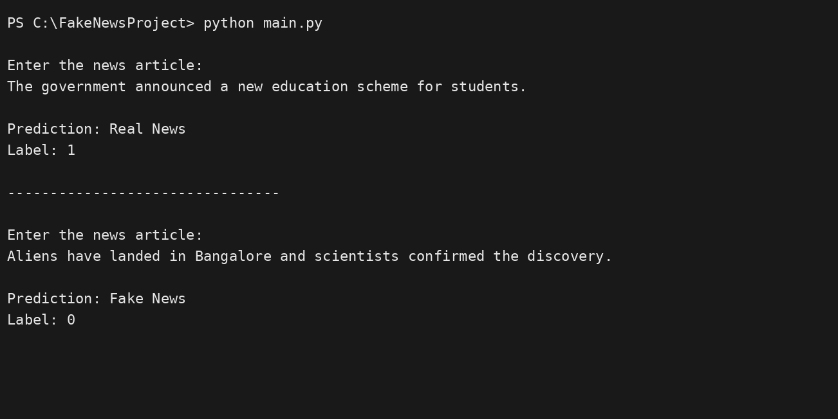
Fake News Detection project steps and PyCharm main.py outputs into an Excel file.
It contains:
- Project Steps sheet — Step name, output, and details
- PyCharm main.py Outputs sheet — the output for every step, ready to use in your project documentation.
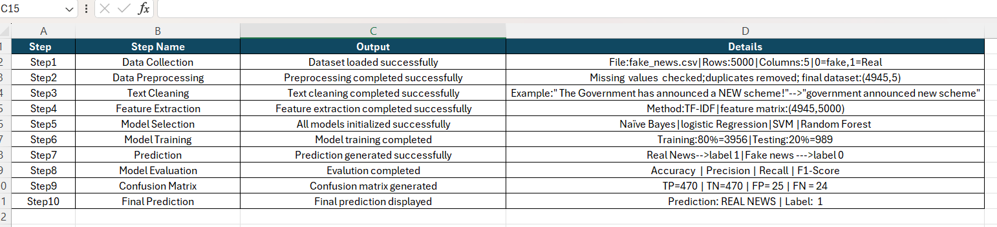
7. System Modules
The Fake News Detection System is divided into six main modules. Each module performs a specific task in detecting whether a news article is fake or real.
1. Data Collection Module
This module is responsible for collecting the news dataset from sources such as Kaggle, CSV files, or News APIs.
Functions:
- Collect news articles.
- Store news title, text, author, and label.
- Prepare the dataset for further processing.
- Labels are assigned as:
  - 0 → Fake News
  - 1 → Real News
2. Text Processing Module
This module prepares the news text for machine learning using NLP techniques.
Functions:
- Convert text to lowercase.
- Remove punctuation and special characters.
- Remove stopwords such as is, the, a, an.
- Tokenize the text.
- Apply stemming or lemmatization.
- Produce clean text for feature extraction.
Example:
Original:
"The Government has announced a NEW scheme!"
After processing:
"Government announced new scheme”
3. Feature Extraction Module
This module converts the cleaned text into numerical data that machine learning algorithms can understand.
Techniques used:
- Bag of Words (BoW)
- TF-IDF
TF-IDF can identify the importance of words in news articles and represent the text as numerical vectors.
4. Model Training Module
This module trains machine learning models using the extracted features.
Algorithms used:
- Naive Bayes
- Logistic Regression
- Support Vector Machine (SVM)
- Random Forest
The dataset is divided into:
80% → Training Data
20% → Testing Data
The models learn patterns from previously labelled Fake and Real news articles.
5. Prediction Module
This module predicts whether a new news article is fake or real.
Process:
New News Article
↓
Text Processing
↓
Feature Extraction
↓
Trained ML Model
↓
Prediction
Output:
0 → Fake News
1 → Real News
For example:
Input: New news article
Output: Real News (1)
6. Visualization Module
This module presents the results in a simple and understandable visual form.
Visualizations can include:
- Accuracy comparison of ML models.
- Confusion matrix.
- Fake vs Real news distribution.
- Precision, Recall, and F1-score comparison.
- Bar charts and graphs.
Example:
Model Accuracy
SVM ███████████████████ 95%
Logistic Regression ██████████████████ 94%
Random Forest █████████████████ 93%
Naive Bayes ████████████████ 91%

8. Expected Output
The expected output of the Fake News Detection System using Machine Learning and NLP is to provide an automated and understandable result for a given news article.
1. Classification of News
The main output of the system is to determine whether the given news article is Fake or Real.
The user enters a news article, and the system processes the text using NLP techniques. The trained machine learning model then predicts the category.
- Fake News (0) – The model predicts that the article is fake or misleading.
- Real News (1) – The model predicts that the article is real.
Example:
Input:
Government announces a new education scheme.
Output:
Prediction: Real News
Label: 1
2. Accuracy Report
The system will generate an accuracy report to measure how well the machine learning models classify news articles.
The following evaluation metrics can be used:
- Accuracy – Measures the overall percentage of correct predictions.
- Precision – Measures how accurately the model identifies a particular class.
- Recall – Measures how many actual articles of a class are correctly identified.
- F1-Score – Provides a balance between precision and recall.
The results of different algorithms can be compared to identify the model that performs best on the selected dataset.
3. Graphs for Model Comparison
The system will generate graphs to make the model results easier to understand.
For example, a bar graph can compare the accuracy of:
- Naive Bayes
- Logistic Regression
- SVM
- Random Forest
The graph helps users quickly identify which machine learning algorithm gives better performance.
Overall Expected Result
The system is expected to:
- Accept a news article as input.
- Process and analyze the text using NLP.
- Predict Fake News or Real News.
- Display the prediction to the user.
- Generate an accuracy and performance report.
- Display graphs comparing the machine learning models.
- Help demonstrate the effectiveness of Machine Learning and NLP in detecting fake news.
9. Advantages
The Fake News Detection System using Machine Learning and NLP has several advantages that make it useful for identifying false or misleading information.
1. Fast and Automated Detection
The system automatically analyzes news articles and predicts whether they are fake or real. It reduces the time required for manual verification.
2. Reduces Misinformation Spread
By identifying potentially fake news quickly, the system can help reduce the circulation of false or misleading information.
3. Useful for Social Media Platforms
Social media platforms receive a huge amount of user-generated content. This system can help flag potentially fake news for further checking.
4. Scalable System
The system can process a large number of news articles. It can be expanded by using larger datasets and improved machine learning models.
5. Saves Time and Human Effort
Manual fact-checking requires significant time and effort. An automated system can perform the initial classification much faster.
6. Uses Machine Learning
The system can learn patterns from previously labelled news articles. With suitable training data, machine learning models can improve their ability to classify new articles.
7. Uses Natural Language Processing
NLP allows the system to analyze important characteristics of written news, such as words and their frequency, instead of simply treating the article as plain text.
8. Multiple Models Can Be Compared
The project can use different algorithms such as:
- Naive Bayes
- Logistic Regression
- SVM
- Random Forest
Their performance can be compared using accuracy, precision, recall, and F1-score.
9. Easy to Understand Results
The final output is simple:
Fake News (0)
OR
Real News (1)
Graphs and confusion matrices also make the results easier to understand.
10. Cost-Effective
Once developed, the system can automatically process articles without requiring continuous manual checking for every individual article.
10. Limitations
Although the Fake News Detection System using Machine Learning and NLP is useful for identifying potentially false information, it has some limitations.
1. Depends on Dataset Quality
The performance of the machine learning model depends heavily on the quality and size of the training dataset. If the dataset contains incorrect labels, biased information, or insufficient examples, the model may produce inaccurate predictions.
2. Cannot Detect Satire Easily
Satirical or humorous news can sometimes look similar to fake news. Since the system mainly analyzes the textual patterns, it may classify satire as fake news even when it was not intended to be presented as factual information.
3. May Struggle with New Types of Fake News
Fake news techniques can change over time. New styles of misinformation may not be present in the training dataset, so the model may have difficulty correctly identifying them.
4. Limited Understanding of Context
Machine learning models may not fully understand the real-world context behind an article. Two articles can use similar words but have completely different meanings.
5. Language Dependency
If the model is trained mainly on English news, its performance may be lower when processing news written in other languages or mixed languages.
11. Future Enhancements
The Fake News Detection System using Machine Learning and NLP can be improved in the future by adding advanced technologies and additional features.
1. Deep Learning Models – LSTM and BERT
In the future, advanced Deep Learning models can be used instead of traditional machine learning algorithms.
- LSTM (Long Short-Term Memory) can understand the sequence and context of words in news articles.
- BERT (Bidirectional Encoder Representations from Transformers) can understand the context of words by considering the surrounding words in a sentence.
These models may improve classification performance when sufficient training data and computing resources are available.
2. Real-Time Browser Extension
A browser extension can be developed to analyze news articles while users are browsing the internet.
For example:
User opens a news article
↓
Browser Extension
↓
Fake News Detection System
↓
Fake / Real
The extension could display a warning or information message when an article is predicted to be potentially unreliable.
3. Multilingual Fake News Detection
Currently, many fake-news detection systems focus mainly on English. In the future, the system can be expanded to support multiple languages such as:
- Kannada
- Hindi
- Tamil
- Telugu
- Malayalam
- Marathi
- Bengali
This would make the system more useful for users from different regions.
4. Integration with Social Media Platforms
The system could be integrated with social media platforms to analyze news content shared by users.
It could help flag potentially misleading content for further review and provide users with additional information before they share it.
5. Real-Time News Analysis
The system could be connected to news APIs so that newly published articles can be analyzed automatically rather than relying only on a static dataset.
6. Improved Explainability
A future version could explain why an article was classified as fake or real, such as highlighting important words or features that influenced the prediction.
This would make the system easier for users to understand and trust.
7. Continuous Model Updating
The model could periodically be retrained using new, verified news articles. This would help it adapt to new writing styles and emerging misinformation patterns.
These enhancements can make the system more accurate, flexible, multilingual, real-time, and useful across different platforms, while still requiring reliable fact-checking and quality training data.

12. Conclusion
The Fake News Detection System using Machine Learning and NLP provides an automated approach to identifying potentially fake or real news articles. The system processes the text of a news article, extracts useful features, and applies machine learning algorithms to classify the content.
1. Uses Machine Learning and NLP
The system combines Natural Language Processing (NLP) and Machine Learning techniques. NLP is used to clean and process the news text, while machine learning algorithms learn patterns from previously labelled news articles and classify new articles as Fake (0) or Real (1).
2. Helps Identify Misinformation
The system can quickly analyze large numbers of news articles and provide an initial classification. This can help users identify potentially misleading or false information before accepting or sharing it.
3. Supports Digital Literacy and Trust
By making users more aware of the possibility of misinformation, the system can encourage people to think critically, check sources, and verify information before sharing it. This supports better digital literacy and responsible use of online information.
4. Provides Measurable Results
The project evaluates different machine learning models using Accuracy, Precision, Recall, F1-Score, and Confusion Matrix. This helps determine how effectively the models perform on the selected dataset.
Final Conclusion
In conclusion, the Fake News Detection System using Machine Learning and NLP demonstrates how artificial intelligence techniques can be applied to an important real-world problem. It provides a fast and automated way to classify news and can serve as a supporting tool for identifying potential misinformation. With future improvements such as BERT, LSTM, multilingual support, real-time analysis, and browser integration, the system can become more useful and effective in promoting responsible digital information consumption.

